

|  |
| --- |
| Introduction to Information Technology  COSC2196  RMI-CPT110 |
|  |
| Assignment 3: Team Project  Group Fourteen |



Contents

Welcome to Group Fourteen 3

Who are we? 3

Meet the team 4

Group Processes 10

Career Plans 10

Tools 12

Project Description 13

Overview 13

Detailed Description 13

Plans and Progress 13

Roles 13

Scope and limits 13

Tools and Technologies 13

Testing 13

Timeframe 13

Risks 13

Group Processes and Communication 14

Skills and Jobs 15

Position Descriptions 15

Project Idea 16

*Open Your Eyes*: A proposal for moral choice frameworks in gaming 16

Reflections 26

Individual reflections 26

Group reflection 26

Appendices 27

Appendix 1: GitHub Repository History (Sample) 27

Appendix 2: Group Discord Discussions (Sample) 28

# Welcome to Group Fourteen



## Who are we?

We’re a small and focused team of individuals from a diverse range of backgrounds and from many walks of life. We all have one thing in common. We are passionate about technology and we have been since before it was cool. Meet the team and learn more about the talents that power this unique company.

## Meet the team

### Nicholas Young

RMIT Student # s3793515

[Assignment 1 Profile](https://njyoung95.github.io/NJYWebsite/)

|  |  |
| --- | --- |
| ***“Ever since I was old enough to understand how to use computers, I have been constantly attached to them in some way, shape or form...”*** |  |

Young in name and in age, but don't let that deceive you. After completing high school Nicholas continued to pursue his interest in IT and studied both IT Networking and Level Design, and it currently studying his Bachelor of IT at RMIT. He discovered his natural affinity for all things IT while still young at high school, when he fixed a troublesome network issue using nothing but research and tenacity. Nicholas has self-taught himself many skills along the way through helping people with their own IT issues, which he then uses as an opportunity to further develop his own knowledge. In particular he has applied his self-learning ability to game level design, which he has pursued for a number of years, and has successfully designed his own levels for games. Aside from his pursuing further knowledge in game design he is also very interesting in developing his knowledge on IT networking.

### Lee van den Blink

RMIT Student # s3792973

[Assignment 1 Profile](https://leevdb.github.io/Lee-van-den-Blink/)

|  |  |
| --- | --- |
|  | ***“I'm incredibly inspired by the design and innovation that is continuously driving the games industry, which I feel runs in parallel with the IT industry and its technology...”*** |

With a decade long history in the vocational education sector, Lee has worked with database management and server management in both small and medium businesses. She is passionate about ‘clean data’ and using data analysis to paint a picture of what is really happening in a company based on the database information. Lee has also rolled out numerous upgrades to IT infrastructure and been responsible for training staff in new applications and software. She was first exposed to computers through playing 80’s adventure games with friends in primary school, and as technology improved her curiosity and involvement with technology has only increased. Being a teenager when floppy discs and dial up internet were still a thing, Lee sees that the world of IT has evolved so vastly and there's so much more to learn, and she wants to learn as much about it as she can. Being that technology and computers have been a part of her life for so long, it's no great surprise that Lee is an avid gamer in her spare time, which is somewhat limited these days as she’s also looking after her young family while working part time. Alongside video games she also enjoys playing netball and learning more about the world through listening to any number of the shows in her massive podcast library.

### Michael Seymour

RMIT Student # s3040138

[Assignment 1 Profile](https://mdncb.github.io/assignment1/)

|  |  |
| --- | --- |
| ***“My interest in IT comes from a life-long interest and curiosity in computers, although I am only now pursuing it with the goal to support myself professionally...”*** |  |

After leaving Australia 7 years ago on a one-way ticket to travel the world, Michael currently calls Moscow his city of residence, where he teaches English. He main interest is the pursuit of knowledge. A Bachelor of Arts graduate, Michael has continued his education into the IT industry, with a keen interest in learning more about software engineering. Seldom does he have downtime, as when he is not at work, he is often studying university, or any number of other online education. You could say studying is his biggest hobby, as he has completed numerous online courses to further his own knowledge on subjects, including maths, computer science and programming languages. Like many members of Group Fourteen, his interest in IT was first piqued at a young age with the family computer. He has witnessed the speed of evolution of the industry, and now understands that the world of IT has the ability to influence society, seeing first hand the differences between countries that have supported infrastructure, and those that are lacking. A few years ago Michael decided to remove himself from all social media, feeling the intrusiveness and ambiguity of the services far outweighed any benefit. This directly links with his interest in cybersecurity and privacy issues, where he hopes to specialise in his future career.

### Cory Atkinson

RMIT Student # s3775626

[Assignment 1 Profile](https://attikins.github.io/Attikins.github.io/dist/about.html)

|  |  |
| --- | --- |
|  | ***“Even to this day I believe there is so much more potential in the current 3D art and design market that hasn't yet been explored...”*** |

The seed for the idea of a career in IT was first planted in Cory at the young age of 10, by playing Halo: Combat Evolved on the XBOX. Unlike most other players at the time who just enjoyed the gameplay, Cory was intrigued by more than the game itself, but everything going on behind it: the hardware, the game mechanics, programming, the design. The seed took root and he pursed this interest further and while a teenager he learnt programming and even made his own “terrible 3d Games” to learn more about the craft around his passion. Fast forward to today and Cory passion about game design has only increased. Cory sees the potential for 3D art and design to be better and bolder, and he sees his current studies with RMIT as a big step towards learning more about his passion. His other main interests which he also approaches with passion and creativity are coffee and metal music.

### Nathan Christos

RMIT Student # s3788418

[Assignment 1 Profile](https://atamosmusic.github.io/itprofile-assessment01.git.io/)

|  |  |
| --- | --- |
| ***“A career in electronics has only fueled my desire to explore the fundamentals of computational processing and machine language...”*** |  |

Currently based in sunny Queensland where he works with electronic security and surveillance issues, Nathan originally grew up in a farming community in NSW. He was home schooled from a young age and it seems his quest for learning and knowledge was present from his early youth, as he continuously scored well above the curriculum standards. Eventually his natural curiosity for learning crossed paths with IT in the form of his family’s first computer. Nathan realised that computers were not magic, but machines, that could be understood and mastered. He has followed this curiosity with IT to a career in electronics, and plans to continue building on his insatiable quest for understanding by studying his Bachelor of Information Technology. Already being involved in electronics through his career, Nathan has many ideas for IT based projects and hope through further study he could bring these to fruition. His strong desire to always improve and master his skills has also been applied to his many and varied other interests which include archery, playing music professionally, being a Kung Fu Master, and being able to solve a Rubik’s cube!

### Harrison Williams

RMIT Student # s3791005

[Assignment 1 Profile](https://harryw77.github.io/Assignment_1/Index.html)

|  |  |
| --- | --- |
|  | ***“My interest in IT has been long running as my dad is very tech savvy, and introduced me to computers at a young age...”*** |

Harrison currently resides in Melbourne, and after VCE completed a year of Bachelor or Psychology, before deciding to pursue his interest in Information Technology, while also working as a baker's apprentice. When he's not rolling dough his enjoys listening to and playing music, reading, and gaming online with friends. His interest in information technology was stirred from youth, and he learned a great deal from his father who was more tech savvy than most, learning about things like running from the command line to use dosbox. This interest grew more in primary and high school, where Harrison found himself being Mr.-fix-it for everyone else’s It issues, thus enabling him to delve deeper into his own understanding of computers and systems. He found a natural affinity with computers, and also learnt he really enjoyed being able to help others and fix their issues. He pursued this interest further and taught himself HTML coding and python language, however baker’s hours don’t currently allow him much chance to continue this interest. He has decided to undertake a Bachelor of IT, as he believes there is great potential for him to find employment in an area he thoroughly enjoys, with the longer term goals of finding work in areas such as coding, connectivity systems, and servers and networking.

## Group Processes

## Career Plans

### Ideal Jobs

|  |  |
| --- | --- |
|  | **Ideal job** |
| Cory | Game Programmer |
| Harrison | Infrastructure Manager |
| Lee | Game Programmer |
| Michael | Software Engineer |
| Nathan | Technical Lead |
| Nicolas | Lead Technical Designer |

As our group is made up of many gaming enthusiasts, it’s not really that surprising that four of the six ideal jobs listed are linked to the games industry. The biggest overlap in experience requirements are knowledge and experience in development of software. There are many overlapping skills also focused around network administration and knowledge. Five of the six roles listed one or more programming skills, with the exception of the infrastructure manager. This was probably the biggest overall area of overlap of requirements.

Half of the jobs listed also required a formal education (specifically the two game programmer roles, and the software engineer role), whereas the other roles were more concerned with experience in the required skills ahead of listing a required formal qualification (although this could also be implied due to the nature of the previous experience required). Nathan’s ideal job of Technical lead had many serverless technologies listed as desired knowledge and seems to be focused on working with the leading edge of the latest technology, which makes it unique in this aspect compared to the other roles. Harrison’s role of Infrastructure Manager was the most heavily based in network, virtualization and security and these types of skills would be utilised in a wide number of businesses.

In the area related to personal attributes, the ability to work in a team, and having strong communication skills were paramount to all six roles, which clearly demonstrates that no matter which area of IT you want to be ultimately work in, having great communication and the ability to work effectively in a team are fundamental to your success, regardless of your individual specialisation.

## Tools

For this project the main communication and sharing tools used were:

* GitHub
* Discord

### Group Website Links

Group website:

<https://groupfourteen.github.io/assignment3/>

Group Git repository:

<https://github.com/groupfourteen/assignment3>

### Reflection on GitHub History

# Project Description

## Overview

Topic

Motivation

Landscape

## Detailed Description

Aim

Goal/s

## Plans and Progress

## Roles

## Scope and limits

## Tools and Technologies

## Testing

## Timeframe

## Risks

## Group Processes and Communication

# Skills and Jobs

## Position Descriptions

# Project Idea

## *Open Your Eyes*: A proposal for moral choice frameworks in gaming

Moral Choice Systems (MCSs) are by no means a new concept in gaming. A staple especially of role-playing games, MCSs serve to immerse the player in the game world, to add depth to characters, to add replay value, and to facilitate multiple endings. But like all game mechanics, MCSs can be implemented well, or badly. The purpose of this essay is to explore what separates a good MCS from a poor one, and proposes a game with an ideal MCS in place.

Where there is interaction with non-player characters (NPCs), there is an opportunity to bring a MCS into a game. Commonly, moral choices are presented as dialogue options. Alternatively, moral choices may be presented as voluntary actions for the player to perform or choose not to perform. The player might have more than one way to solve a quest. Or, the moral choice may be a factor in how the player behaves in the game world. MCSs seek to add depth and characterisation to NPCs, to add an element of realism, and to trigger emotional investment in a game.

### What makes a good or bad MCS?

Rather than adding depth, a poorly-implemented MCS can make a game feel shallow. This commonly occurs when the MCS ultimately leads the player towards only one of two options: "good" and "evil". This black and white approach renders any morally grey choices, or inconsistent behaviour from the player, effectively meaningless: the player will either be rewarded as the great saviour, or maligned as an incarnation of evil, despite any actions or choices they made during the game contrary to the end result.

Worse still, this black and white approach can be taken to an even more shallow extreme when, of the moral choices presented, one is obviously preferred over another. Typically, this leads to the player being punished for freely choosing the "wrong" (evil) option over the "right" (virtuous) one. Another common problem with poorly-implemented MCS is where the choices a player makes during the game carry little to no weight on the game’s ending. What appears to be branching paths and depth of characters is revealed to be an illusion in the final act, and the game’s endings are restricted to choices which are made in the final moments.

A poorly-designed MCS detracts from the game experience, and in many cases games with poor examples such as those mentioned above would mostly likely have been better off with cutscenes rather than token attempts at player choice.

A good MCS should affect the outcome of the game in such a way that the player feels like the choices they made during the game carried weight: choices should make the player feel conflicted; there should be no 'obviously correct' path to take to fulfil the game designer's vision of the plot. Alternatively, the player could be confronted with decisions which do not seem to alter the plot significantly, but which add incremental changes to the game experience of the unaware player. In either case, it is generally ideal for the results of the player's actions not to be immediately obvious.

It could be thought that the less intrusive the moral choices are, the stronger the overall effect. An amalgamation of player choices throughout the game, creating subtle changes in the way NPCs react and respond to the player, is far more effective in immersing the player in the game world than an NPC reacting, predictably, badly to an obviously "wrong" dialogue option.

### Good MCSs and bad MCSs: some examples

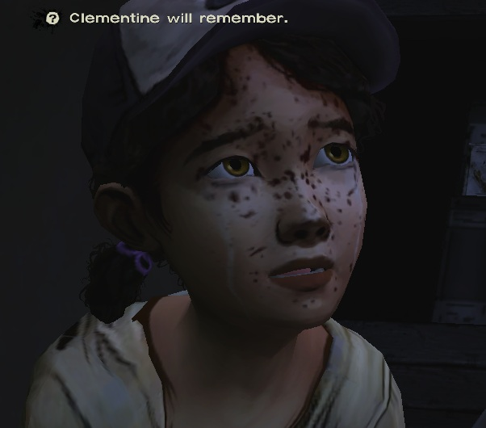Telltale Games's *The Walking Dead* series are notable examples of games where moral choices affect the outcome of certain situations. However, in many cases these fall victim to the flaw of player choices being rendered meaningless in the interest of plot continuity: where there are sequels in production, there is limited variety in endings so as to avoid a long episodic series becoming fractally complicated. Instead, players may be faced with options which produce little to no difference to the scene but provide an illusion of player control, such as the infamous "[NPC] will remember that" subtext which often appears on screen but rarely seems to carry a strong influence on the plot.

The Walking Dead. Clementine will remember that. Maybe.

On the other hand, *The Walking Dead* series also features some good examples of moral choice dilemmas: in one scene, the player must choose between saving an NPC from zombies and sacrificing supplies, or sacrificing an NPC and supplies[1]. If the player chooses to sacrifice the NPC, the player then hears that character screaming and dying in the background. It is a good example of a decision carrying weight, and the player being forced to confront the result of their decision. Here, the immediate result of their decision is used in a purposeful way: it is designed to trigger an emotional response of regret and guilt from the player, but also produces invisible results as that NPC can no longer interact with the player for the rest of the game.

The controversy around the ending of *Mass Effect 3* is remembered as a particularly egregious example of player choices throughout the game being rendered meaningless in the last scene[2]. The Mass Effect series had established itself as games which incorporated a lot of player freedom of choice and multiple endings. In *Mass Effect 3* however, the fate of the entire universe is decided by dialogue trees in the final scene. All choices the player made up to this point in the game were suddenly revealed to have had no impact on the plot, to the chagrin of the game's fanbase.

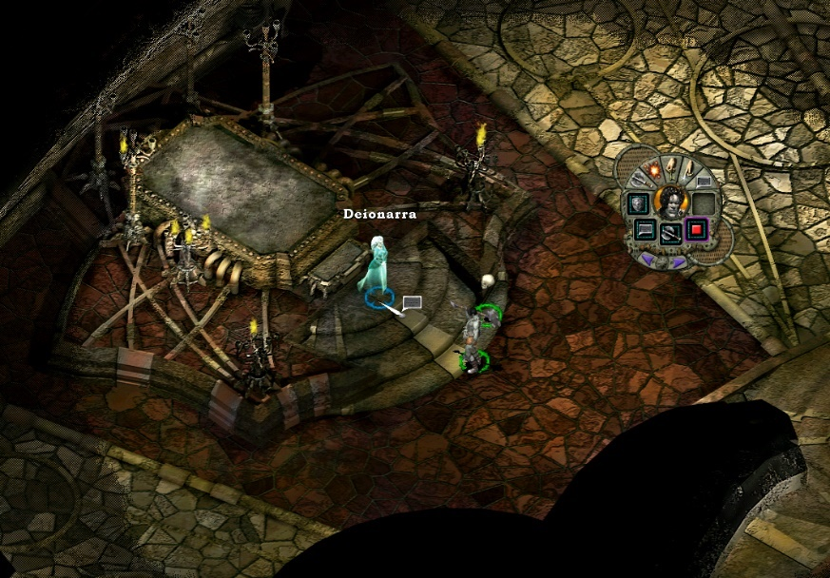An example of a game with a well-executed MCS is the 1999 game *Planescape: Torment*. An isometric role-playing game, *Planescape: Torment*'s plot is primarily dialogue-driven, and the player develops the main character’s alignment (good, chaotic, lawful, neutral and other variations), and develops the plot primarily through dialogue, although the weight of these choices is rarely apparent. The results of player choices may not become apparent until much later in the game. In many cases, branching paths are not clearly delineated, and the player may be unaware that the plot path they are following is not predetermined[3].

Planescape: Torment. What can change the nature of a man?

In this way, the personality of the main character is malleable, and therefore the reactions and interactions with NPCs also differs with each playthrough. It also means that seeking alternative endings requires more than saving the game in the last room: alternative paths are created by playing the entire game differently, thus the game retains a lot of replay value.

Another example of a good MCS is *Spec Ops: The Line* which, on first appearance, is a typical first-person war shooter. Nevertheless, it implements moral choices and branching paths where the results are not immediately obvious to the player. The player typically will play the game as one would with any typical first-person shooter, but later in the game the player is confronted with the consequences of their earlier actions, thus subverting the player’s expectations about the nature of the genre[4].

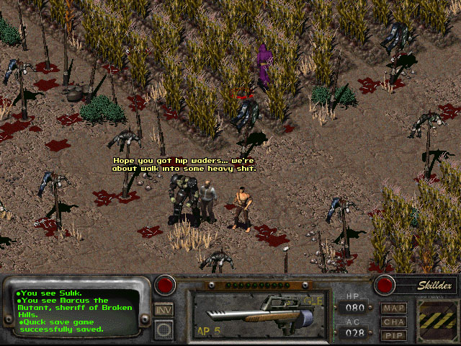Before it became a AAA title, early entries in the *Fallout* franchise, particularly *Fallout 2*, were notable examples of games which encouraged player choice with few restrictions. In *Fallout 2*, the player could play the game in virtually any manner they desired. The player could role play as a purely virtuous character, or a genocidal maniac; *Fallout 3* and further sequels were noted for the inability to kill child NPCs, but no such restrictions exist in the early games. Furthermore, the player could become a slaver, or a pimp, or a variety of other morally questionable occupations in line with the principle of player freedom of choice. These choices, however, all impacted permanently on how NPCs would interact with the player[5].

Fallout 2. Choose your path wisely.

In *Grand Theft Auto V*, by contrast, the player can act morally questionably towards NPCs but the results are not long-lasting: they expire when the player dies, is arrested, or successfully evades police contact for an arbitrary amount of time. Although fun and cathartic, the temporary nature of the MCS in *Grand Theft Auto V* is tokenistic, and does not impact on, or develop, the plot or the characters[6].

Based on the above examples and others, some criteria elevate a moral choice above others, in terms of player immersion and replay value. These criteria include:

|  |
| --- |
| *Distinct endings require distinct playthroughs:* |
| Alternative endings should not, for example, be simple variations on one “main” ending with variations of flavour text. A player ought to develop their character differently throughout the course of the game in order to discover significant variations in the plot. |
| *Avoid "good/evil" dichotomies:* |
| NPCs should be written with pathos, and stereotypes of virtue and evil should be strictly avoided. Immersion develops when players feel connected to multifaceted character who possess depth and complexity, as people connect to and sympathise with other people. |
| *All decisions should carry weight:* |
| All decisions and actions the player makes should impact the game in some way: whether it adjusts a background statistic or alters the entire course of the plot, every interaction should carry some weight. The consequences of actions should carry short-term and long-term effects, and these effects may (and often should) conflict with each other: for example, a player may make a pragmatic decision for the short-term benefit but create a long-term detriment. To this end, immediate consequences should be obvious, whereas long-term effects should be subtle. The player should not necessarily be aware that any particular decision has definitively altered the game. |
| *The player must care about consequences:* |
| Moral choices should make the player feel a moral conflict: the player should feel that there are no “correct” options, but rather “actions with consequences”. |
| *Saving the game state should be limited:* |
| By restricting the ability to save in the middle of a scene, the player is forced to commit to, and confront, the consequences of their decisions. An alternative option would be to skip to beginning of game chapters (as they are unlocked), and also to maintain a persistent state of autosave (in the style of GTA V). In this way, the player can skip to specific points in the story to investigate branching paths without returning to the very start of the game, while still maintaining the emphasis on living with decision made within these phases on the game. As long as the player is not forced into an unwinnable state (i.e. "dead man walking"), this should produce a suitable balance of player control, and gravitas on player decisions. |

With this in mind, we would like to propose a game concept which aims to encompass all of the above points.

### The Batavia Mutiny

The 1629 mutiny of the VOC vessel Batavia has been overshadowed by numerous other extraordinary events of the Age of Sail: while it lacks the familiarity of the 1789 mutiny of HMS Bounty, it lacks none of the drama and intrigue. In fact, it dwarfs it in terms of historical significance, and in bloodiness[7].

In designing a game around a true historical event, the shortcomings of artificial MCSs become immediately apparent. Convincing depictions of NPC personalities demand complexity to mirror the people they represent. Even the main antagonist, Jeronimus Cornelisz, had a deep and complex history which saw him develop from a privileged childhood into a man who enthusiastically ordered the deaths of around 100 people. Even for a man like that, depicting him as a stereotypical evil character would be a mistake; purely evil personalities repel, yet Cornelisz could irresistibly attract people to follow his commands.

A modern replica of Batavia

It is precisely this paradoxical quality of people which leaves so much potential for exploration in a MCS, if it extends beyond the good/evil dichotomy. The title of this project, *Open Your Eyes*, is based on the etymology of the word *abrolhos*: a corruption of Portuguese for “open your eyes”, or “keep your eyes open”. Appropriate, considering the difficulty in sighting a low-lying reef at sea, but in this case it is also connected to the principle of keeping one’s eyes open to the consequences of one’s actions as well as to the physical danger which the player, along with the other NPCs, will find themselves in during the course of the game. Keeping one’s eyes open to all characters and events is the key to story progression.

Considering the aspects which benefit a MCS, together with this historical event in context, we propose the following features of a MCS in our game based on the Batavia mutiny:

|  |  |
| --- | --- |
| Two distinct Acts | The first Act takes place on board Batavia during the outward journey and ends with the ship running aground. The second Act takes place in the Houtman Abrolhos, primarily on Batavia’s Graveyard (today knows as Beacon Island), but also on Traitor’s Island, Long Island, and East & West Wallabi Islands depending on player choices. |
| Multiple Stages within the two Acts | Each act to contain multiple branching paths which directly impact on the next Stage. Autosaving at the beginning of every Stage and Act; no saving within a Stage. The player may replay a stage but may not save within a Stage with the aim of immediately backtracking to see the alternative option. In this way, the player is given the change to retrace their steps but must still commit to any choices they make within the game. |
| Limited Save Points | With this save policy, it is vital to limit or remove any “dead man walking” scenarios where the player becomes trapped in an unwinnable situation. There should always be at least one branching path which can lead the player to the end of the game, and not to a death scene regardless of choice. Although they may not reach the end scene they wanted, it should always, at least in theory, be possible to “escape the room”. |
| NPCs must be relatable | As all the NPCs are based on real people it should become easier to empathise with them. Based on historical records, we can make good estimations as to the temperament of most of the significant characters in the game, and they should be programmed accordingly. By taking this approach, all NPCs should seem more realistic, leading the player to become concerned for their well-being and feel moral conflicts about the impact of their choices. |
| Decisions Matter | Decisions the player makes must impact the course of the game on the micro and macro level; as the game is split into two distinct Acts, decisions the player makes in the first Act, i.e. on board Batavia, performing tasks and generating relationships with various NPCs, will directly impact the second Act when the player is stranded on the island. For example, if the player performs routine tasks for the Overmerchant in the first Act, the player may begin the second Act with a reduced standing among the mutineers, possibly putting him or her in danger. However, not performing routine tasks as ordered may place the player in reduced standing with the Overmerchant, and they may miss opportunities to gather important information about mutineers (and opportunities to form bonds with them) which may increase their prospects of survival in the second Act. |
| NPCs have Intelligence | NPCs should possess some AI which leads them to interact organically with the player and other NPCs. Ideally, this will be based on something similar to the Big Five personality traits, with individual characteristics increasing or decreasing in strength throughout the course of the game as they are influenced by game events and player actions. |
| Multiple Distinct Endings, including: | * The player is murdered (although this must be signposted); * The player survives without joining any faction; * The player joins the mutineers and is ultimately hanged on the island after the rescue ship arrives (as the most serious offenders historically were); * The player joins the mutineers but avoids punishment (as, historically, some did); * The player joins a faction of marooned soldiers on another island and defeats the mutineers after the rescue ship arrives; * The player joins the marooned soldiers but is defeated by the mutineers; * Finally, as an alternate-history 'Easter egg ending': the player joins the mutineers, defeats the soldiers, commandeers the rescue ship on arrival, and survives to become a pirate. This ending, however, should be extremely difficult to achieve as indeed it would be, fighting off two larger factions simultaneously. |

It is our belief that, with the right story, characters and setting, a MCS can elevate a game dramatically. In basing a game on a historical event, natural humanity comes into the game as one surely wants to treat the memory of those involved in such a traumatic event with respect.

With the knowledge that real, ordinary people experienced this event, it brings the event to life once more through the game: placed in the same situation, would you do everything it takes to survive?

One of several mass graves of the Batavia mutiny. Beacon Island, WA.

#### Citations & Acknowledgements:

Picture sources:

*Morality*. (2019). [image] Available at: <https://psmag.com/.image/t_share/MTI3NTgyNTA4NDU0ODEyMTI2/morality-illo.jpg> [Accessed 10 Apr. 2019].

*Clementine Will Remember*. (2019). [image] Available at: <https://verbalspew.files.wordpress.com/2013/10/twdep5-clementine-will-remember.jpg> [Accessed 10 Apr. 2019].

*The Nameless One and Deionarra holding a conversation*. (2019). [image] Available at: [https://upload.wikimedia.org/wikipedia/it/a/a0/The_Nameless_One_and_Deionarra_holding_a_conversation_(PT).png](https://upload.wikimedia.org/wikipedia/it/a/a0/The_Nameless_One_and_Deionarra_holding_a_conversation_(PT).png%20) [Accessed 10 Apr. 2019].

*Fallout 2*. (2019). [image] Available at: [https://killapenguin.com/227/gallery/medium/fallout2/fallout-2-0012.jpg](https://killapenguin.com/227/gallery/medium/fallout2/fallout-2-0012.jpg%20) [Accessed 10 Apr. 2019].

*Batavia replica under sail*. (2019). [image] Available at: [http://www.heinz-kratz.de/batavia1.jpg](http://www.heinz-kratz.de/batavia1.jpg%20) [Accessed 10 Apr. 2019].

*Beacon Island grave*. (2019). [image] Available at: [https://images.thewest.com.au/publication/B88714996Z/1516155255791_G581DOK9V.3-1.jpg?imwidth=800&impolicy=.auto](https://images.thewest.com.au/publication/B88714996Z/1516155255791_G581DOK9V.3-1.jpg?imwidth=800&impolicy=.auto%20) [Accessed 10 Apr. 2019].

# Reflections

*Refer to* *Appendix 1: GitHub Repository History – Sample* *for evidence of GitHub commit history.*

*Refer to* *Appendix 2: Group Discord Discussion – Sample* *for evidence of use of Discord.*

## Individual reflections

### Nicholas Young

### Lee van den Blink

### Michael Seymour

### Cory Atkinson

### Nathan Christos

### Harrison Williams

## Group reflection

# Appendices

## Appendix 1: GitHub Repository History (Sample)

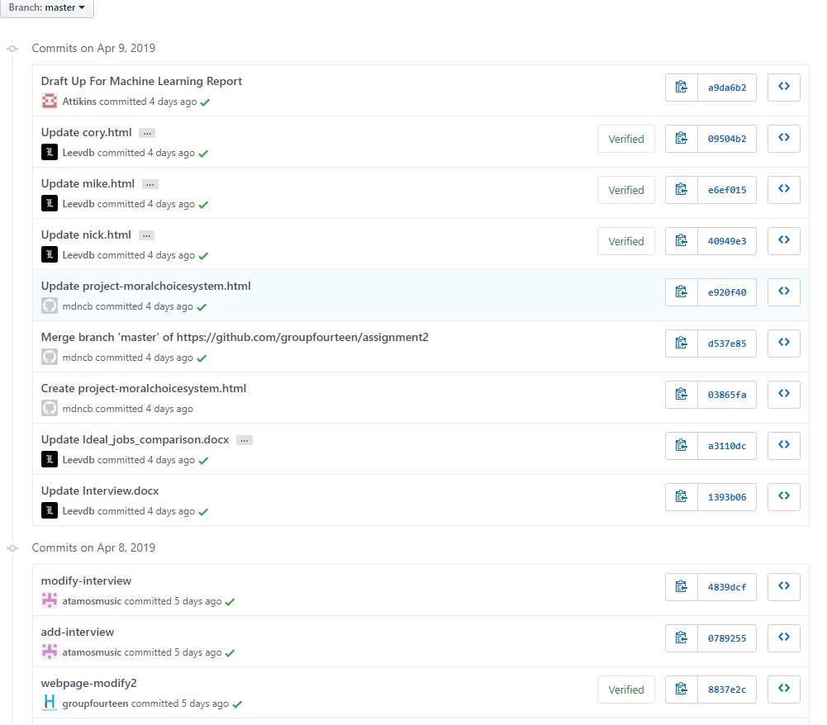

## Appendix 2: Group Discord Discussions (Sample)

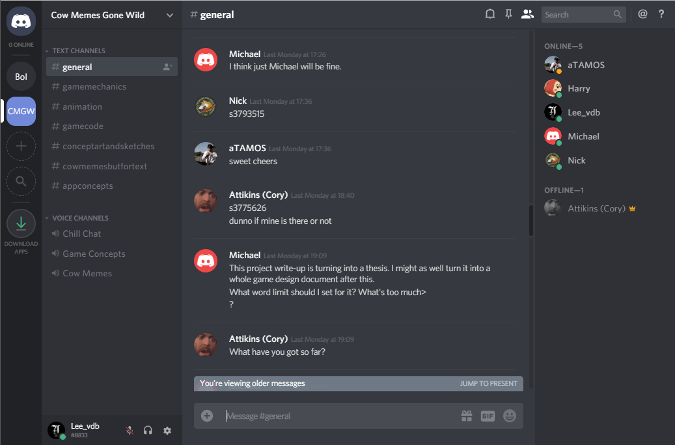

1. Lee Leaves a Woman as a Live Bait for Walkers (The Walking Dead | Telltale Games). (2019). [video] Available at: https://www.youtube.com/watch?v=H2OgM31qUYU [Accessed 10 Apr. 2019].
2. IGN. (2019). *Controversies - Mass Effect 3 Wiki Guide - IGN*. [online] Available at: https://www.ign.com/wikis/mass-effect-3/Controversies [Accessed 10 Apr. 2019].
3. En.wikipedia.org. (2019). *Planescape: Torment*. [online] Available at: https://en.wikipedia.org/wiki/Planescape:_Torment [Accessed 10 Apr. 2019].
4. YouTube. (2019). *SPEC OPS: THE LINE (Zero Punctuation)*. [online] Available at: https://www.youtube.com/watch?v=HNhPMjbgkXA [Accessed 10 Apr. 2019].
5. Gamestudies.org. (2019). *Game Studies - Moral Decision Making in Fallout*. [online] Available at: http://www.gamestudies.org/0902/articles/schulzke [Accessed 10 Apr. 2019].
6. GTA Wiki. (2019). *Wasted*. [online] Available at: https://gta.fandom.com/wiki/Wasted [Accessed 10 Apr. 2019].
7. En.wikipedia.org. (2019). *Batavia (ship)*. [online] Available at: https://en.wikipedia.org/wiki/Batavia_(ship) [Accessed 10 Apr. 2019].